2023 GAA BOD Meeting minutes

4 April 2023
Meeting Start time 7:00 P.M.
Attendance: 14 members
Bobby Slaton - President (No vote -unless to break a tie+)
John Chandler – Ace Apache’s
Danny Pincus – Every Arrow Counts
Lee Ford Faherty – Mid GA Archery Club
Cassey Pelton -Southern Eagles Archery (GAA Secretary)
Tiffany Holzman – Eagle Creek JOAD
Fredrina Slaton – Smashing Arrows (Archery Club) (GAA Secretary)
Terry Weistrick -
Mariabelen Romero – Atlanta Archery Club
James/Jake Martin -Team on point
Thadrick Heaney – South Georgia JOAD (GAA Vice President)
Also in Attendance: First time attending (No Vote)
Shantelle Mitchell – KAC Archery Club President
Heather Polk – Kennesaw Archery Club
Leo Kim – K Archery Club
Call meeting to Order – Bobby Slaton

Financial Report information:

Financial Report
Board of Director’s Meeting April 4, 2023

Wells Fargo Starting Balance as Feb. 03, 2023 $24,425.00
Income
Interest Paid 1.90
Crown Awards Credit .96
Sub Balance $24,427.86
Expenses
Crown Awards (25 Meter Shoot Awards) $ 46.08
USA Archery Association Fees 500.00
Postage 48.80
Just Awards (Redesigned GAA Medals) 5,010.00
Meeting Expense 15.99
Expenses total 5,620.87
Total Available Balance 4/4/23 $18,806.99
__________________________________________________________________________________

Bank of America Current balance is 2/1/2023 $26,225.52
Income
(NO INCOME TO REPORT)
Expenses
Funds moved to Wells Fargo $24,425.00
Crown Awards (JOAD Indoor & GA Cup Awards) 836.41
Square Space subscription 540.00
Expense total 25,801.41
Bank of America Total Available Balance 4/4/23 $ 424.11

Old Business:
Outdoor Upcoming meets
Georgia Cup
June 3rd - 4th 2023 (Two Day event. Cost $80 per archer)

2023 JOAD Outdoor State Championship
July 8th, 2023 (One Day event - $50 per archer)

State Outdoor Championship
September 2nd, (One day event -$50 per archer)

2023 State Field Championship
October 7th, 2023 (One day event - $50 per archer)

- By-Laws Corrections (needs to be voted to accept the updates)
We voted to approve the red line corrections only. The updated By-Laws will be sent out to everyone this week.
Motion to approve By-Laws Corrections – Terry Wiestrick
Seconded – John Chandler
All were in agreement of By Law Corrections

- Update on Amendment for Officer’s travel Expenses
We will not add the reimbursements to the GAA By-Laws. Instead, we will write a policy using Google Documents. The documents wording will be voted on next BOD meeting. Potential wording, “Officers that travels more than twenty miles from their home on record will be reimbursed by GAA for mileage at the rate of $0.60 cents per mile for GAA business only.” No Hotel or food reimbursements will be given to officers. Clarity example: Officer will not be reimbursed if attending an event that the officer is acting as a coach to that officer’s athlete or team. A motion was made to work on the wording for the policy.
Terry Wiestrick and Lee Ford will work together to draft a policy for the board to review.

No vote was needed for this subject.

- Update on equipment inventory log/tracking system and rental.
We need to find a suitable place to store all of the items GAA owns and create an informational tracking sheet for all of the items. Bobby will work with Mariabelen Romero to work on an information tracking sheet for all GAA items once he has had a chance to inventory the storage trailer.

We also need to see what’s in the trailer that GAA owns to decide what should be done with the items. Bobby mentioned that he’ll make a date with Rhonda to visit the trailer at some point. He will let everyone know the date he will be going to see the trailer in case anyone wished to go.

No vote was needed for this subject.

- New GAA Medals have been ordered and should be here by the end of June.
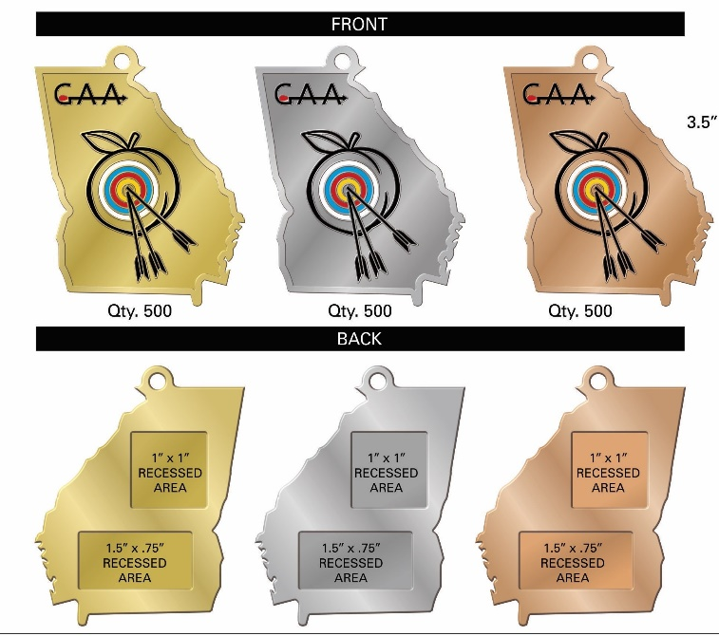

New Business:
- Junior, Senior High School College Exposure Event (Should we use the email and Facebook contact list to advertise this event?)
Motion to approve email for the advertising of the event – Terry Wiestrik
Seconded – Danny Pincus
All were in Agreement

- We will advertise any club in the state of Georgia that will host a Marvel/USA Archery Sanctioned event.
Motion to approve – Cassandra Pelton
Seconded – Terry Weistrick
All were in Agreement

Meeting Closed at 7:54 P.M.
- Motion to close the meeting – Danny Pincus
- Motion Seconded – Terry Weistrick
BOD Meeting minutes – Fredrina Slaton (GAA secretary)

If you see any errors, or need any additions added, email me a info@gaarchery.org

